Andrew Dykman – Software Development Lifecycles – Lab 8

Task 1.)
Question 2, 3.)
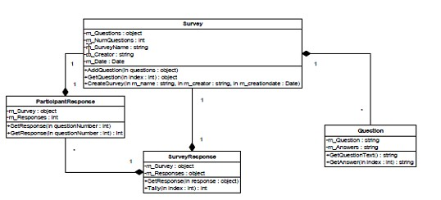
Phase | Classes and Components
Week I | Survey, m_Questions, m_NumQuestions, m_SurveyName, m_Creator, m_Date, AddQuestion, GetQuestion, CreateSurvey
Week II | ParticipantResponse, m_Survey, m_Response, SetResponse, GetResponse, SurveyResponse, m_Survey, m_Response, SetResponse, Tally
Week III | SurveyResponse, m_Survey, m_Responses, GetResponses, TallyUp
Week IV | Question, m_Question, m_Answers, GetQuestion, GetAnswer
Complexity Estimation: 8 Weeks (including Database and Testing)

Question 3, 4.) Survey, ParticipantResponse, SurveyResponse, Question (4)

Question A.) 2 Staff Months. Reasoning: Used a Timetable.

Task 2.)
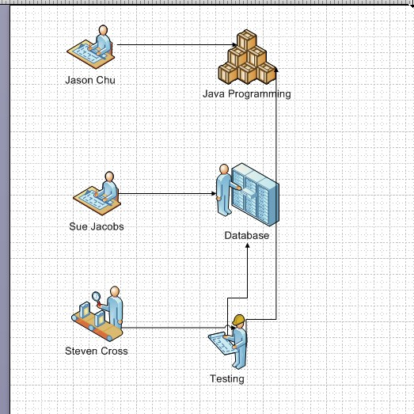
Task 2.) Programming 4 weeks, Database 2 Weeks, Testing 1 Week

Task 3.)
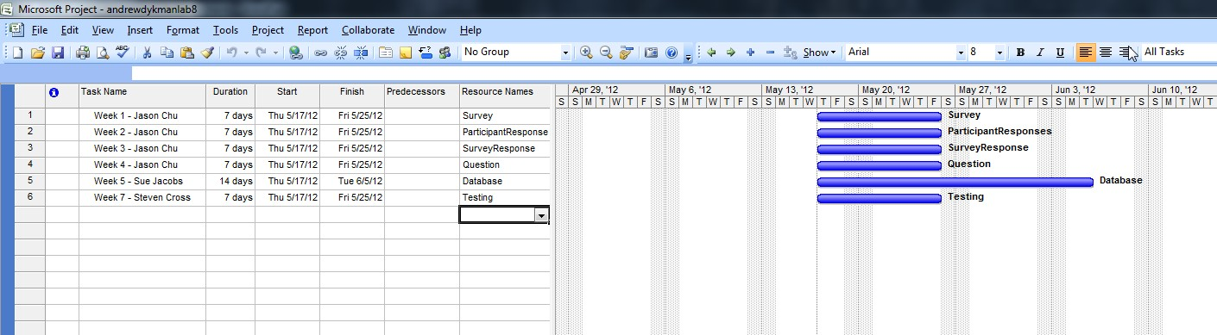
Question B.) Immediately.

Question C.) They don't. Database implementation starts after programming. Testing starts after completion of coding and database.
Question D.) Start date for the question class remains unchanged.

Question E.) No. Work days are 8-hour shifts.
Question F.) No.

Question G.) Any task linked to a major point.

Question H, I, J.) Nothing, Changed because data was modified.

